**Radio Manager**

**User Guide**

**Introduction**

This document is a part of the *Radio Manager* WordPress plugin that is completely free and open-source (MIT licensed). It serves as a user guide and manual for

the plugin. As a new user of this software, you should read the whole guide for

a complete understanding. If you are an advanced user, look at the table of contents below and read the chapter you are interested in.

**Table of contents**

1 Dependencies 1

2 Installation 1

3 Uninstallation 3

4 PART 1: Basics 4

4.1 Features 4

4.2 Different playlist 4

4.3 Shuffle mode 5

5 PART 2: Website 5

5.1 Videos 5

5.2 Images 6

5.3 Description 7

5.4 Description (no images) 8

5.5 Logo 9

5.6 Website posts 10

5.7 Warnings 11

5.8 Preloader 11

5.9 Understand the multimedia rule 12

6 PART 3: Administration 13

6.1 Radio stations 14

6.2 Editing a radio station 14

6.2.1 Name 14

6.2.2 Logo 15

6.2.3 Shortcode 15

6.2.4 Publish 16

6.2.5 Settings 17

6.2.6 Playlist 17

6.2.7 Warnings 19

6.3 Musicians 20

6.4 Editing a musician 21

6.4.1 Name 21

6.4.2 Description 21

6.4.3 Featured image 21

6.4.4 Genres 22

6.4.5 Publish 23

6.4.6 Images 23

6.4.7 Introductions 25

6.4.8 Recordings 26

6.5 Genres 28

7 PART 4: Bonus features 29

7.1 Skipping 29

7.2 Clever images 29

7.3 Extended logo 30

8 Contact 30

# 1 Dependencies

To make the plugin work properly, you must have the following WordPress plugins installed and activated:

* Advanced Custom Fields
* Advanced Custom Fields: Repeater Field
* s2Member Framework

Do not expect 100 % functionality if any of the plugins above is missing. Your website should also have **the Bootstrap library (version 4.6)** installed. Contact your webmaster to get more information about it.

# 2 Installation

We expect you to be an administrator.

1. Contact the creator (see the last chapter) to get a ZIP archive of the plugin.
2. Log into your WordPress account.
3. Go to *Plugins → Add New* in the WordPress navigation menu on the left.

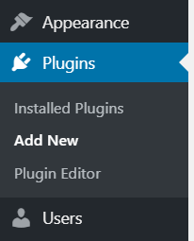

1. Click on the *Upload Plugin* button on top of the page. Find the ZIP archive of the plugin in your computer and click on the *Install Now* button to start

the installation process.

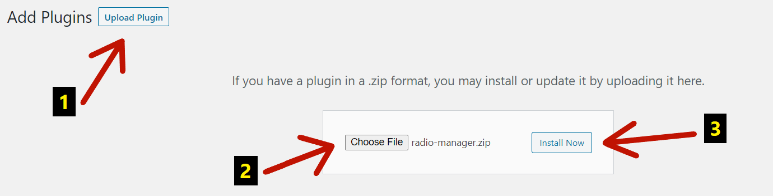

1. After the installation, activate the plugin by clicking on the *Activate Plugin* button.

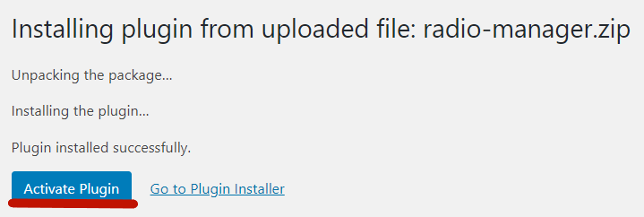

1. Find the plugin in *Plugins → Installed Plugins* and click on the *Help* link nearby to continue reading this user guide right in the website administration.



1. You have successfully completed the installation.

# 3 Uninstallation

We expect you to be an administrator.

1. Log into your WordPress account.
2. Go to *Plugins → Installed Plugins* in the WordPress navigation menu on

the left.

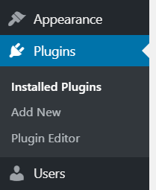

1. Find the plugin in the list and click on the *Deactivate* link nearby.



1. After that, click on the *Delete* link and confirm the uninstallation.



1. You have successfully completed the uninstallation.

# 4 PART 1: Basics

The *Radio Manager* WordPress plugin is a software that enables you to create

e-radios for your website.

## 4.1 Features

An e-radio (also “radio”, “radio station” or “jukebox”) can do the following things:

* play audio/video recordings;
* play audio/video introductions (e.g., entries by an e-radio presenter);
* display images (with the top and bottom title of each);
* display other posts from the website;
* show the musician and recording names;
* show the musician description;
* show the e-radio logo;
* show the e-radio name; and
* show dialogs (so-called “warnings”) that interrupt the playback and prompt the listener to take a certain action.

## 4.2 Different playlist

The **e-radio** has a **playlist**. The playlist is composed of **playlist items** that are being played one after another. But playlist items **ARE NOT** recordings (as one might expect). Every playlist item is a group of music genres you can manage.

A **genre** (e.g., *Folk*, *Classical, Announcements*, *Jingles*, etc.)is a group of musicians. A **musician** is a group of recordings (and also images, etc.).

When the e-radio starts to play, it sets the first playlist item from the playlist. Then,

it sets a music genre from the playlist item and a musician from this genre. Finally,

it sets a recording from this musician to be played (and also images to be shown, etc.). Genres, musicians, and recordings are shuffled (see below). The whole process continues for other playlist items. This is the main principle of all e-radios.

## 4.3 Shuffle mode

*“Shuffle play is a mode of music playback in which songs are played in*

*a randomized order that is decided upon for all tracks at once.” – Wikipedia*

* All the **genres** attached to a particular playlist item are shuffled.
* All the **musicians** attached to a particular music genre are shuffled.
* All the **images**, **introductions**, and **recordings** attached to a particular musician are shuffled.
* If all the genres, musicians, introductions, or recordings were played, they are **shuffled again** (except the images).

# 5 PART 2: Website

You can insert the e-radio into an arbitrary WordPress post or page (details in

the next chapter). After that, there is a blue-styled responsive universal jukebox on the website. The jukebox can do all the things mentioned in the *Features* in

the previous chapter. It is also accessible for all your website visitors who can enjoy it. Let us describe the jukebox and all the situations you may face.

## 5.1 Videos

This is the jukebox playing the *Support Us* video recording by the *CATV USA* musician.

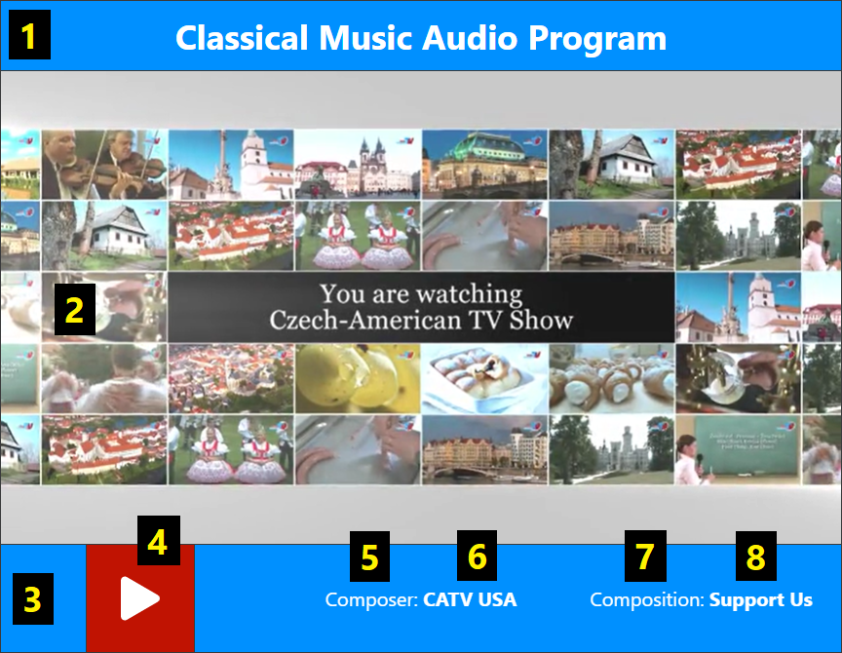

1. A field for the **name** of the e-radio.
2. A field for the **multimedia** (the video in this case).
3. A field for the e-radio **controls and information**.
4. A button that can **play or pause** the playback.
5. A **caption** for a musician’s name.
6. The **musician’s name**.
7. A **caption** for a recording’s name.
8. The **recording’s name**.

## 5.2 Images

This is the jukebox playing the *A Pair in Love* audio recording by the *Vitezslav Novak* musician. It also projects images of this musician (even if you stop

the playback). Each image is shown for a specific length of time (e.g., three seconds). The transition between images is *fade*.

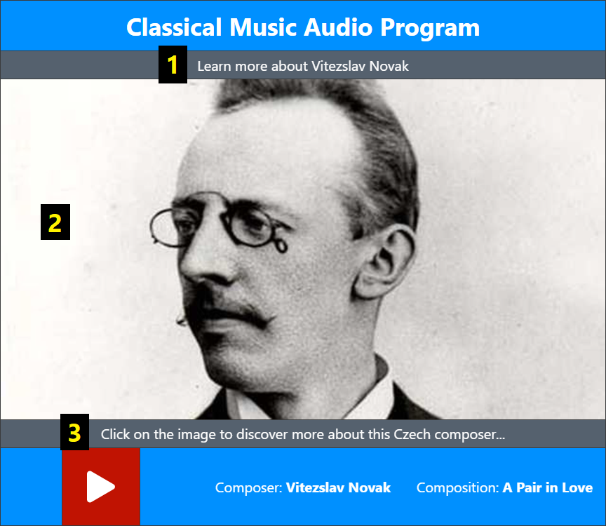

1. The **top title** of the image.
2. The **image** of the musician.
3. The **bottom title** of the image.

## 5.3 Description

In the case of *Images*, you can click on the image. After that, the musician’s description appears.

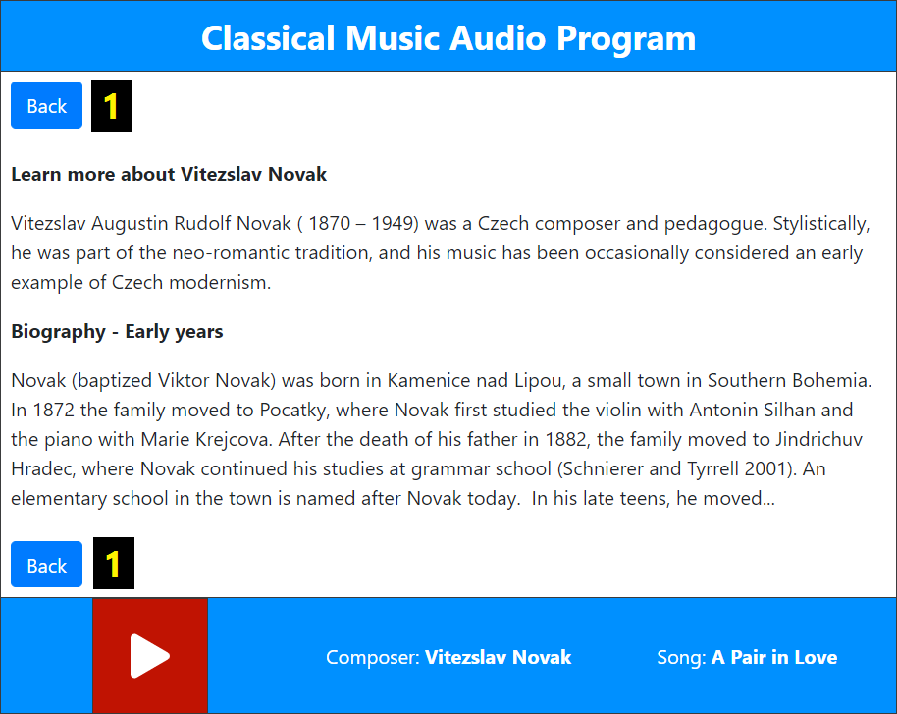

1. With the help of the *Back* buttons, you can return to the image.

## 5.4 Description (no images)

If the musician has no images, the description appears by default (notice that there are no *Back* buttons). If the description is very long, there is a side slider for scrolling up and down.

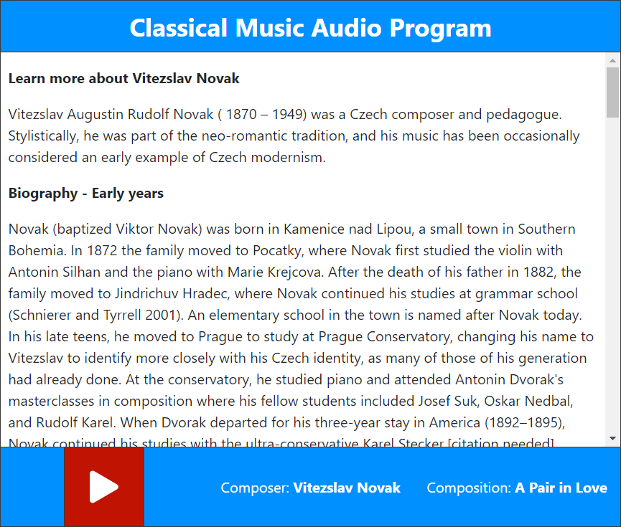

## 5.5 Logo

If there are no images nor description, there is a logo of the e-radio by default.



## 5.6 Website posts

There is the possibility of projecting some website posts in the e-radio. It can be useful if all the musicians have no images nor descriptions. In this case, there is

a **featured image** of that website post accompanied by the top and bottom title of that image. If you click on the featured image, there is the **content** of the website post. The website posts are **shuffled**. A particular post is shown for the whole length of the recording. If the next recording starts to play, another website post appears. For instance, there are no images nor descriptions for the music bands in the Folk Music Audio Program. Therefore, you see the website posts about Czech traditions.

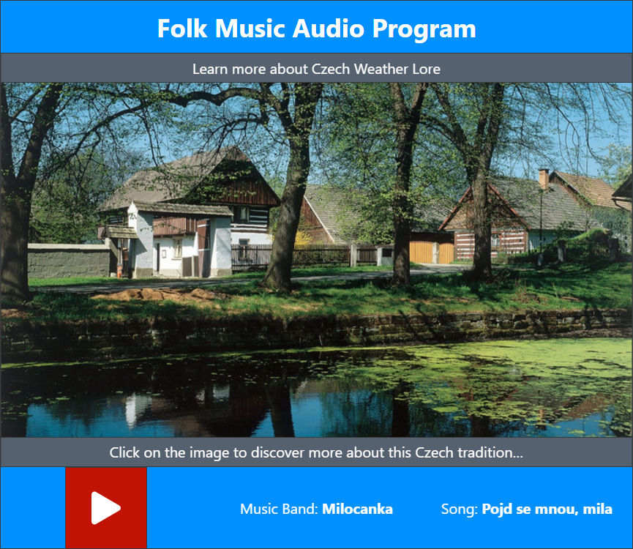

## 5.7 Warnings

These dialogs interrupt the playback and require a listener’s attention. They can be used for example as a prevention against the loss of streaming or as adverts. Every warning comes with a dark grey background to center the listener’s attention onto it.

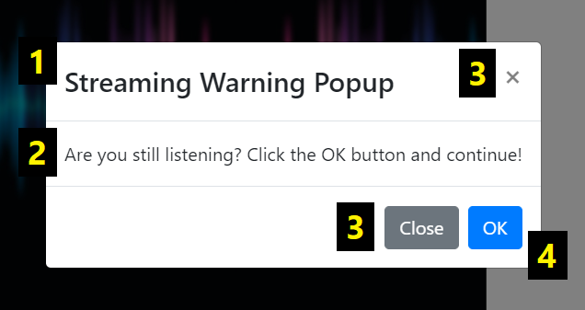

1. The **title** of the warning.
2. The **message** of the warning.
3. The ways to **finish** the warning and continue listening.
4. The *OK* button can finish the warning too, but it can also be used to redirect the listener to a new URL link in a new tab after clicking it.

## 5.8 Preloader

If there is a high-quality image or video, or your internet connection is slow, there is a small white circle turning around while the multimedia are loading.

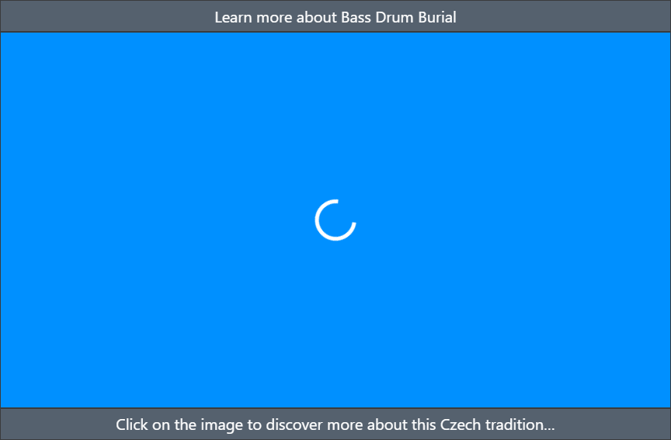

## 5.9 Understand the multimedia rule

This is the multimedia rule:

**Videos > Website posts > Images > Description > Logo**

* If the e-radio plays a **video** recording, everything to the right is hidden.
* If the e-radio plays an audio recording and the **website posts** are activated, everything to the right is hidden.
* If the e-radio plays the audio recording and the website posts are deactivated, there are **images** attached to a musician and everything to the right is hidden.
* If the musician has no images, there is just a **description** of this musician and everything to the right is hidden.
* If the musician has no images nor description, there is a **logo** of the e-radio.
* If the e-radio has no logo, there is simply **nothing**.

# 6 PART 3: Administration

You can manage all the e-radios, musicians, and genres in the WordPress administration. First, log into your WordPress account. After that, move the mouse on the *Radio Manager* item in the WordPress navigation menu on the left.

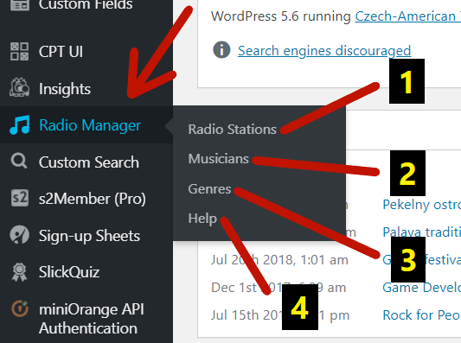

1. There you can manage all the **e-radios**.
2. There you can manage all the **musicians**.
3. There you can manage all the **music genres**.
4. There you can find **this document**.

If you cannot find the *Radio Manager* menu item, you probably do not have

the respective user capabilities. You must be able to **edit posts** at least (in the case of this capability, you can see only *Musicians* and *Help* submenu items). Administrators, editors, authors, and contributors can edit posts by default. Moreover, only administrators can also **manage options** and see the rest in

the image above.

## 6.1 Radio stations

After clicking on the *Radio Stations* item in the submenu, you can see a list with all the existing e-radios.

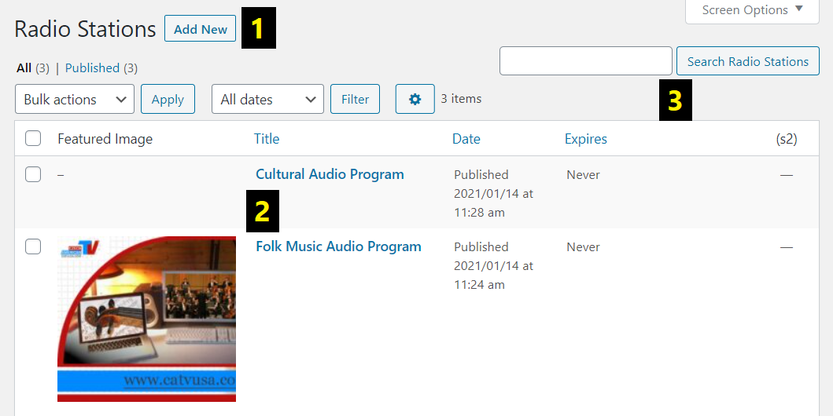

1. There you can **start creating** a new e-radio.
2. There is a **list** of all the existing e-radios that you can manage.
3. There you can **search for** an existing e-radio from the list.

## 6.2 Editing a radio station

After clicking on the specific e-radio or creating a new one, you will land on

the editing page. Let us now consider everything this page contains.

### 6.2.1 Name

The name is shown in the jukebox on top.

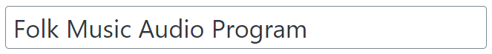

### 6.2.2 Logo

The logo is shown in the jukebox by default.

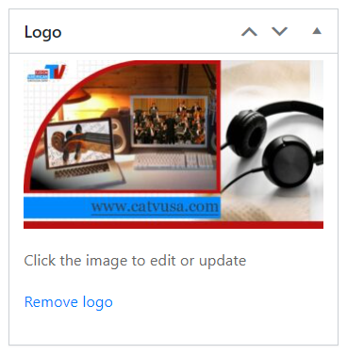

### 6.2.3 Shortcode

This is the way you can **import a jukebox** into an arbitrary WordPress post or page. Just click on the *Copy* button, find a particular post or page, and insert

the shortcode to the content. After opening the post or page on the website, you will see the jukebox.

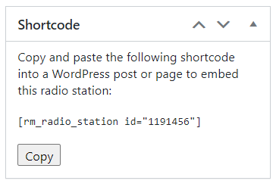

### 6.2.4 Publish

Every time you change something, go here to **update** or **publish** all the changes.

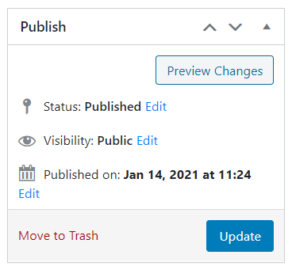

### 6.2.5 Settings

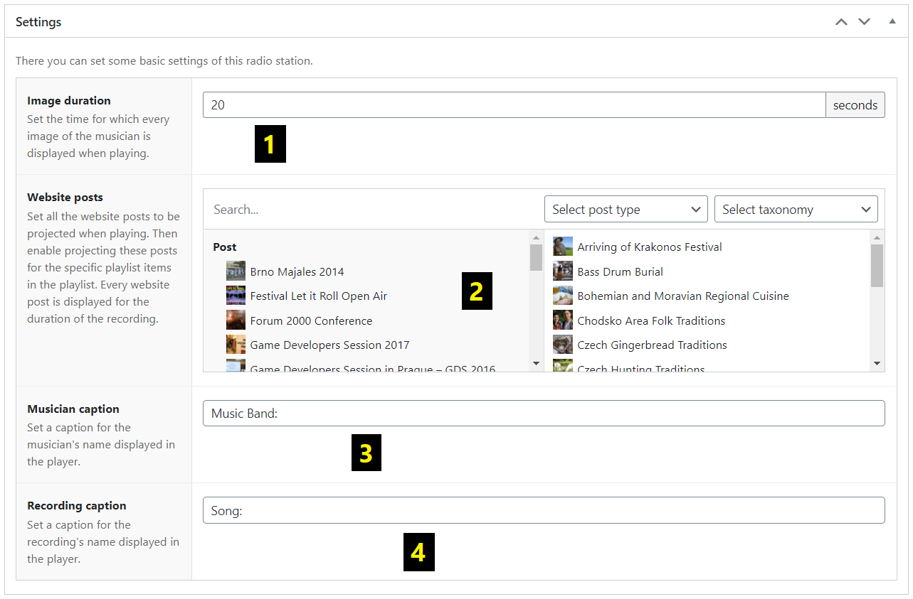

1. *Image duration* – There you can set the time (in seconds) for which every image of the musician is displayed when playing recordings from this musician.
2. *Website posts* – There you can set all the website posts to be projected when playing recordings from the particular musician. But you must enable projecting these posts for the specific playlist items in the playlist below.
3. *Musician caption* – There you can set a caption for the musician’s name displayed in the jukebox.
4. *Recording caption* – There you can set a caption for the recording’s name displayed in the jukebox.

### 6.2.6 Playlist

There you can add, edit, swap, or delete playlist items from the playlist. There must be at least one playlist item. For each of the playlist items, at least one music genre must be set.

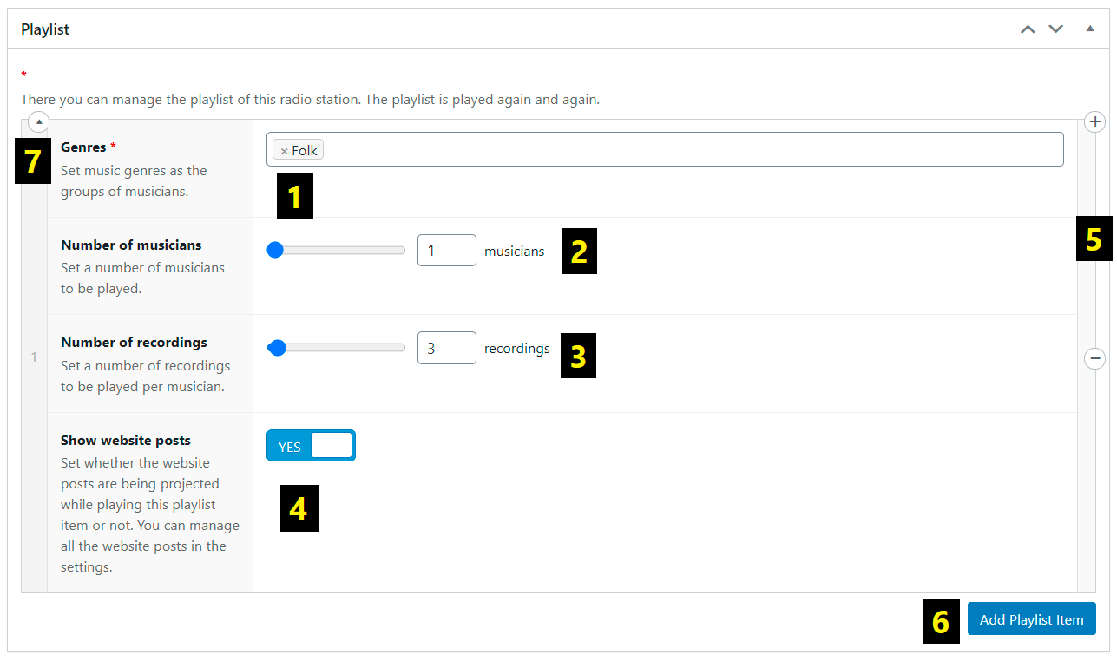

1. *Genres* – There you can set music genres as the groups of musicians.
2. *Number of musicians* – There you can set the number of musicians to be played per genre.
3. *Number of recordings* – There you can set the number of recordings to be played per musician.
4. *Show website posts* – There you can set whether the website posts are being projected while playing this playlist item or not.
5. After moving the mouse on the specific playlist item, you can delete it or even add a new one by clicking on the *Plus* or *Minus* icon on the right.
6. There you can add a new playlist item composed of the previous information – *Genres*, *Number of musicians*, *Number of recordings* and *Show website posts*.
7. After moving the mouse on the specific playlist item, you can collapse or expand it by clicking on the *Arrow* icon in the top left corner of the item.

### 6.2.7 Warnings

There you can add, edit, swap, or delete warnings. For every warning, the message must be set.

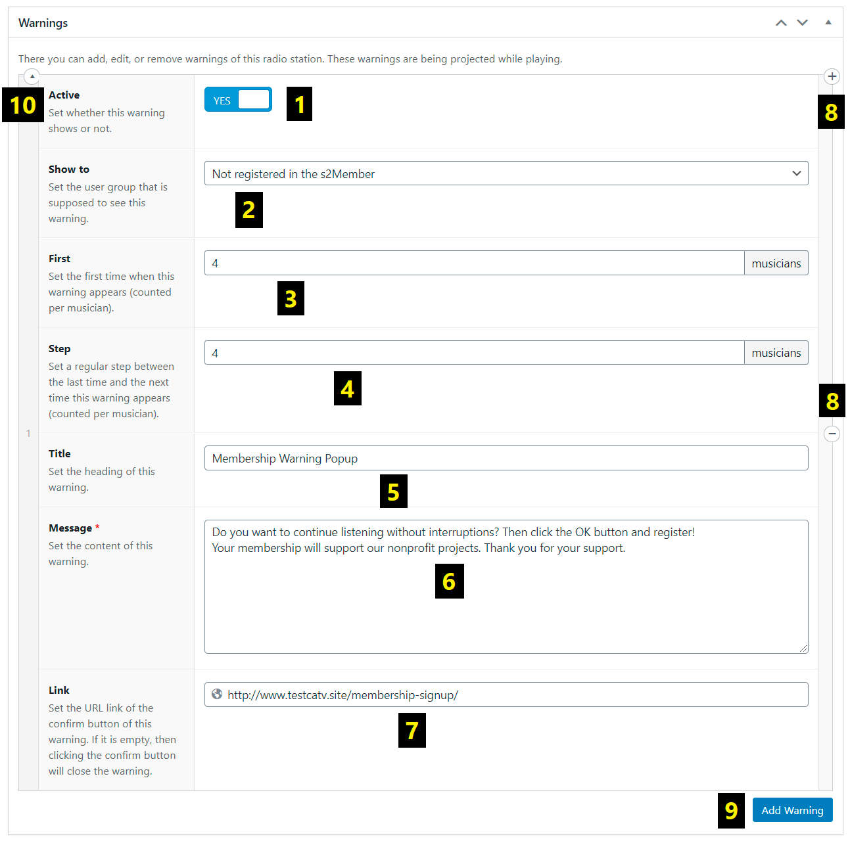

1. *Active* – There you can set whether this warning shows or not.
2. *Show to* – There you can set the user group that is supposed to see this warning (for example *All users*).
3. *First* – There you can set the first time when this warning will appear (counted per musician).
4. *Step* – There you can set a regular step between the last time and the next time this warning appears (counted per musician).
5. *Title* – There you can set the heading of this warning.
6. *Message* – There you can set the content of this warning.
7. *Link* – There you can set the URL link of the confirm button of this warning. If it is empty, then clicking on the confirm button will close the warning. If not, the listener will be redirected to the URL link in a new tab after clicking.
8. After moving the mouse on the specific warning, you can delete it or even add a new one by clicking on the *Plus* or *Minus* icon on the right.
9. There you can add a new warning composed of the previous information – *Active*, *Show to*, *First*, *Step*, *Title*, *Message* and *Link*.
10. After moving the mouse on the specific warning, you can collapse or expand it by clicking on the *Arrow* icon in the top left corner of the warning.

## 6.3 Musicians

After clicking on the *Musicians* item in the submenu, you can see a list with all

the existing musicians.

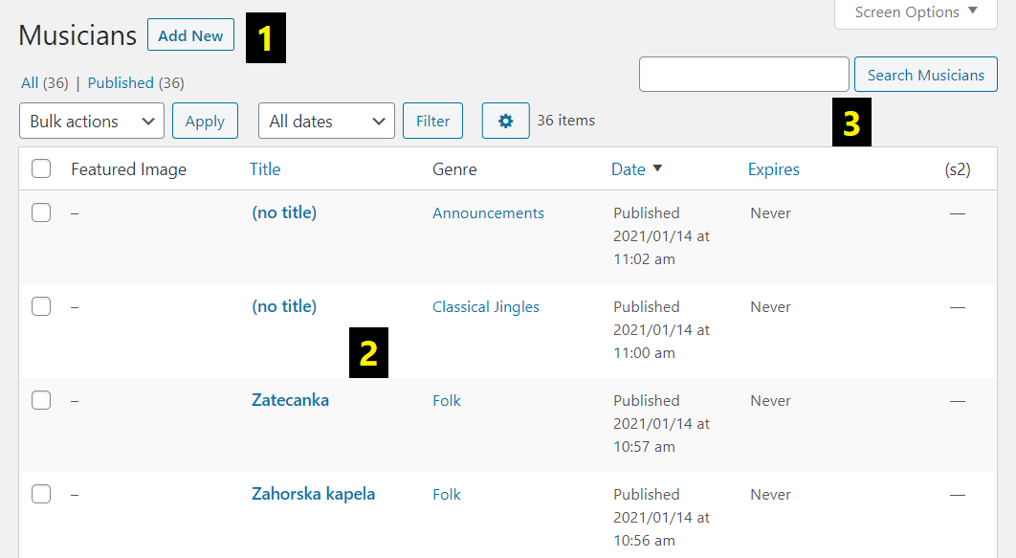

1. There you can **start creating** a new musician.
2. There is a **list** of all the existing musicians that you can manage.
3. There you can **search for** an existing musician from the list.

## 6.4 Editing a musician

After clicking on the specific musician or creating a new one, you will land on

the editing page. Let us now consider everything this page contains.

### 6.4.1 Name

The name is displayed in the jukebox next to the musician’s caption.

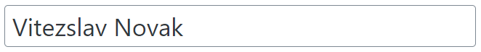

### 6.4.2 Description

The description appears after clicking on the projected images.

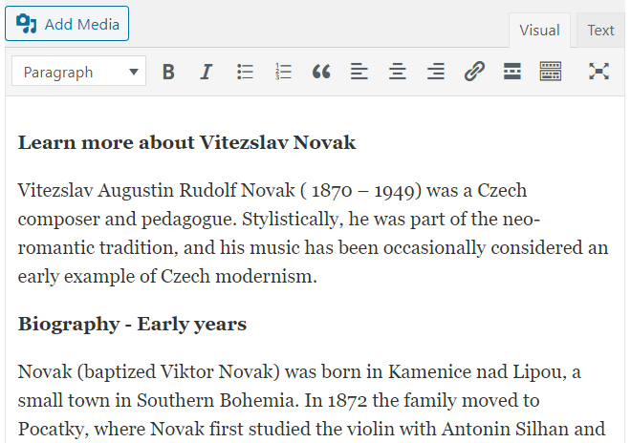

### 6.4.3 Featured image

This image just represents the musician in a list of all the existing musicians. It does not show anywhere in the jukebox.

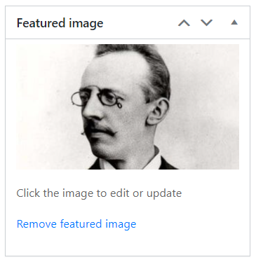

### 6.4.4 Genres

If you assign the musician to a specific genre, he or she can be played in the playlist.

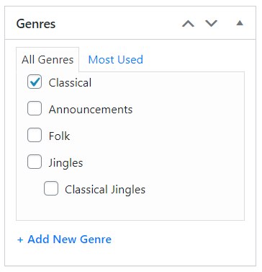

### 6.4.5 Publish

Every time you change something, go here to **update** or **publish** all the changes.

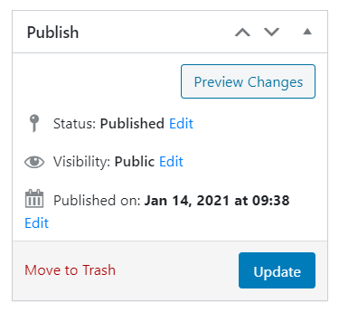

### 6.4.6 Images

There you can add, edit, or delete images of the musician. The images are being projected while playing recordings from the musician. All the images of the musician should have the **same width and height**. To add, if you set a **top title** or

a **bottom title** for one image (see below), it should also be set in the remaining images. If you move the mouse on the image, then the *Pencil*, *Remove*, *Minus* and *Plus* icons appear nearby.

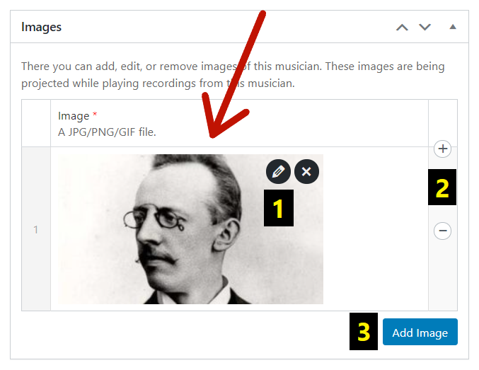

1. By clicking on the *Pencil* icon, you can change the **top and bottom title** of the image.

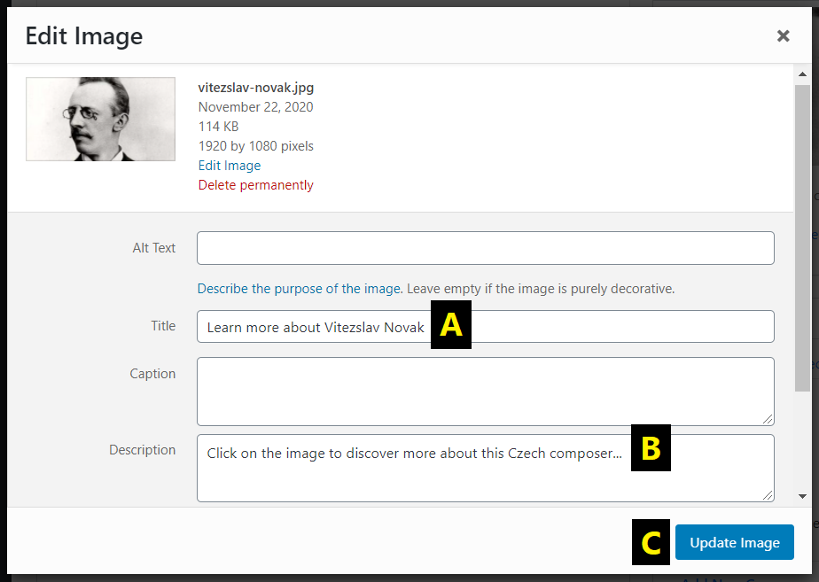

1. There you can edit the **top title** of the image.
2. There you can edit the **bottom title** of the image.
3. There you can **update** all the changes.
4. By clicking on the *Plus* or *Minus* icon, you can **add or remove** the image.
5. There you can **add** a new image (from your computer or the Media Library).

### 6.4.7 Introductions

There you can add, edit, or delete audio/video introductions of the musician. Before playing the recordings of the musician, one of them is set and played. Introductions are **shuffled** and can be used for example as the entries of an e-radio presenter. If you move the mouse on the introduction, then the *Minus* and *Plus* icons appear nearby.

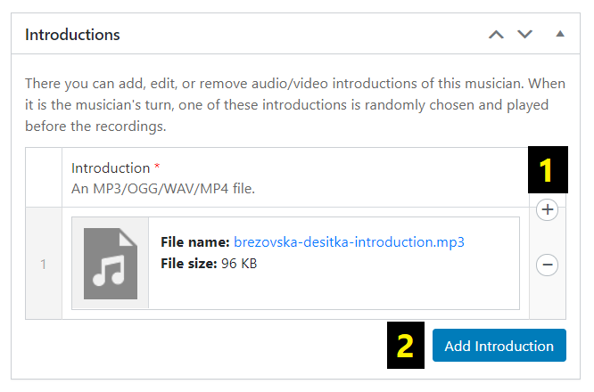

1. By clicking on the *Plus* or *Minus* icon, you can **add or remove**

the introduction.

1. There you can **add** a new introduction (from your computer or the Media Library).

### 6.4.8 Recordings

There you can add, edit, or delete audio/video recordings of the musician. For every musician, there must be at least one recording. If you move the mouse on

the recording, then the *Pencil*, *Remove*, *Minus* and *Plus* icons appear nearby.

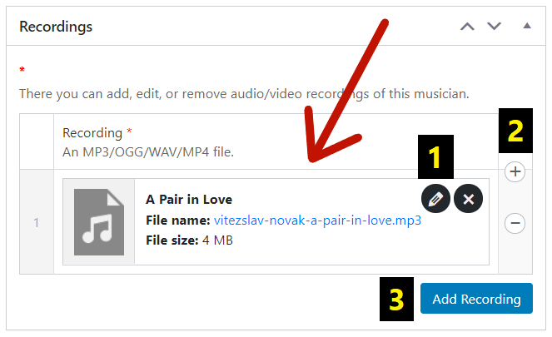

1. By clicking on the *Pencil* icon, you can change the **name** of the recording that is displayed next to the recording’s caption in the e-radio.

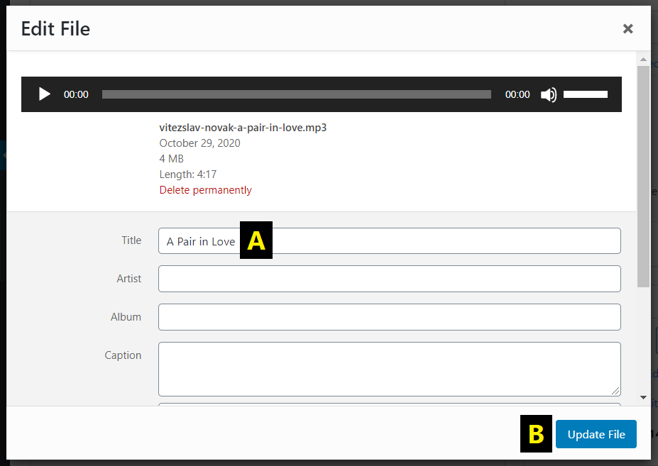

1. There you can edit the **name** of the recording.
2. There you can **update** all the changes.
3. By clicking on the *Plus* or *Minus* icon, you can **add or remove** the recording.
4. There you can **add** a new recording (from your computer or the Media Library).

## 6.5 Genres

After clicking on the *Genres* item in the submenu, you can see a list with all

the existing music genres. Genres are very important for creating the playlist.

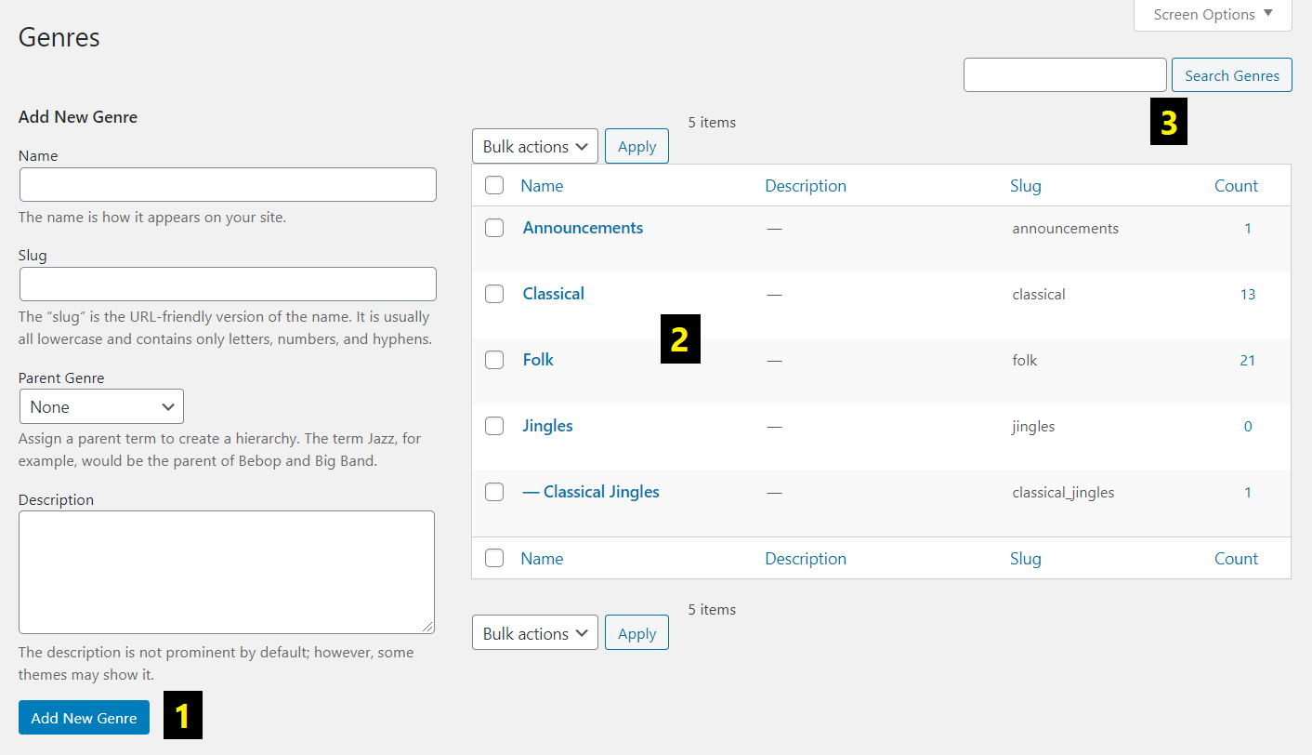

1. There you can **create** a new genre.
2. There is a **list** of all the existing genres that you can manage.
3. There you can **search for** an existing genre from the list.

# 7 PART 4: Bonus features

## 7.1 Skipping

By clicking on the bottom right corner of the e-radio, you can skip the current recording/introduction. This hidden feature is very useful if you just want to test

the playback without having to wait every time until the recording/introduction is finished.

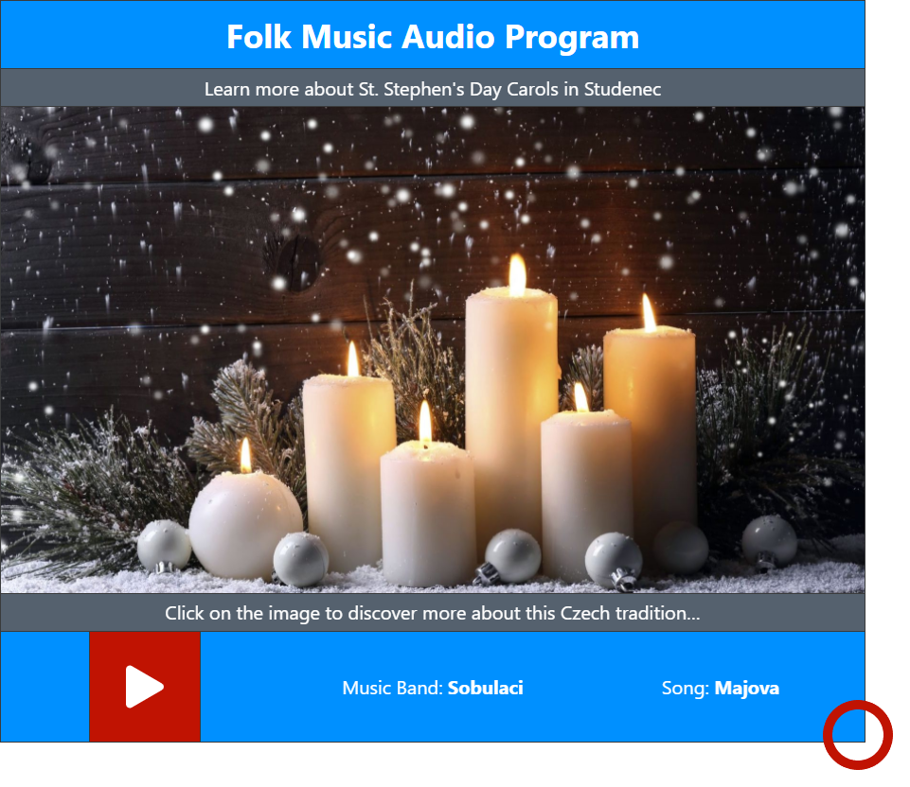

## 7.2 Clever images

If you click on the image of the musician in the e-radio, the musician’s description appears. Then, if you get back with the help of the *Back* button, there is a **different** image than before. In that moment, images are **shuffled**. It works perfectly only if there are a lot of images to show. Otherwise, you will probably see the same image.

## 7.3 Extended logo

The logo of an e-radio can have its top and bottom title too.



# 8 Contact

If you have any troubles or do not understand something, please contact the creator of this plugin.

**Skype:** karelvrabeckv

**E-mail:** [karelvrabeckv@gmail.com](mailto:karelvrabeckv@gmail.com)

Your message helps us to make this user guide and the whole plugin better for understanding.